How to exploit a graph – vocabulary
- Match the words with the corresponding picture :
A line chart a pie graph a bar chart a scatter plot a diagram a table

Age | Number of people
12-24 | 86
25-35 | 32
35-60 | 24
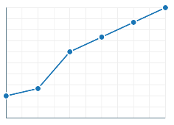
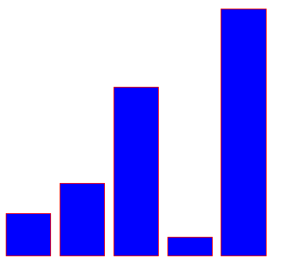
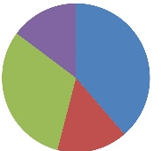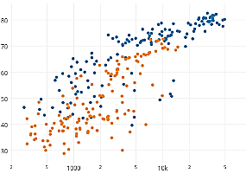

- Match the words with their synonyms :
A sample/a morsel  A datum  A range  An axis  A trend  A pattern |  | A line  A configuration  A figure  A representative part  An area  A tendency

- Put the following words in the right column :
Line going up | Flat line --- | Fluctuating line | Line going down
to rise  to increase  to surge  to soar  to go upward  to rocket  to leap  to reach a peak  to spiral  to shoot up  to be on the upswing | to be constant  to remain stable/unchanged  to reach a plateau  to hover  to be unfaltering | to see-saw  to shift  to vary  to be unsteady  to oscillate | to drop  to plummet  to slump  to plunge  to reach a trough  to bottom out  to sink  to tail off  to nosedive  to tumble

- Put the following adverbs in the right column :
Small evolution | Progressive evolution | Brutal evolution
Slightly  minutely  faintly  marginally  moderately  minimally | gently  gradually  steadily  consistently  continuously  slowly | suddenly  significantly  steeply  sharply  quickly  dramatically  markedly  substantially  considerably

- Describe the following graphs :
Graph 1 :

Description : This is a bar chart showing in what situations Americans accept facial recognition.
Key elements :
- When it’s for safety reasons, a majority of people asked agree with facial recogntion (59% are OK with the police using it) ;
- However, people disagree with companies tracking their employees and even less agree with facial recognition being used for marketing reasons (15%)
- Around 15% of people surveyed consistently respond they are not sure ; 13% of American adults have not heard of facial recognition, showing a lack of information on the subject.

Graph 2 :

Description : This is a bar chart showing the carbon footprint of different industries and people.

Key elements :
- Surprisingly, air travel has a low footprint (1 T of CO2 for a plane trip from New York to San Francisco), compared to 65T for the entire lifetime of a car.
- Depending on where they live, people also have more or less of a footprint : 18T for an American, more than twice as much as a human on average in a year.
- The most surprising is the footprint of AI : training one AI model emits 300T of CO2 !

Graph 3:
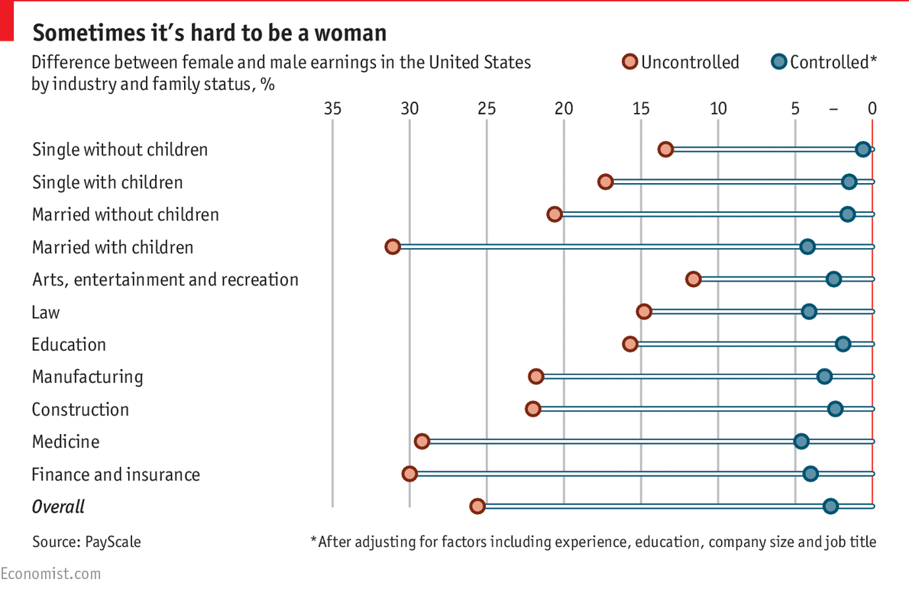

Description : This is a bar chart showing wage inequalities between men and women in the USA.
Key elements :
- The first set of data is “uncontrolled“ : it shows the wage gap between all men and women in specific work branches. In the medical field, for instance, the gap soars to a staggering 29% ; but the most dramatic difference is for people married with children : women in that category earn 32% less than men !
- However, the second set of data contrasts that : it shows the “controlled“ figures, meaning that it compares people with the exact same education, experience and jobs (comparing nurses with nurses, not surgeons with nurses for instance). The wage gap drops significantly : in the medical field, it tumbles to 4% for instance. This shows that in reality, men and women do not occupy the same jobs, and women tend to be in positions that pay less – that explains the massive gap with the uncontrolled data.
- Yet, we can’t help but notice that even though it is moderate, the gap is still there ! How can it be explained that women having the exact same education, experience and jobs still earn on average 3% less than men ?

