Picture 1 : Dave Whamond (Canada), Cagle Cartoons, 2019.
Printed after the New York Times decided to stop publishing cartoons in 2019.
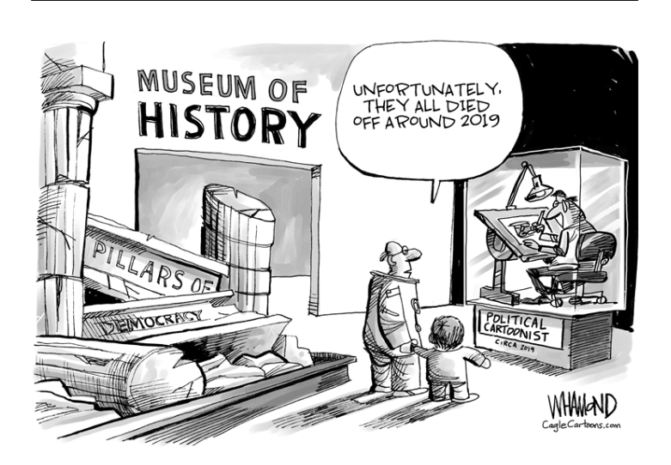
Picture 2 :
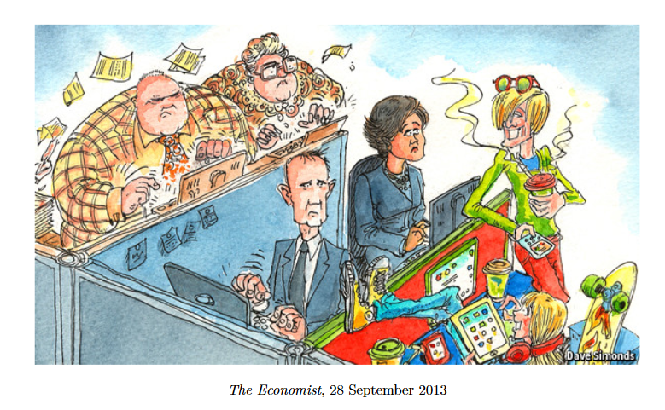
Description :
- A cartoon from The Economist depicting three generations at work.
Key elements :
- While older generations, including boomers and Gen X, are focused on their work, millennials are doing anything but work : they are drinking coffee, scrolling on their phones and are not even sitting in a respectful way. This generation seems lazy and entitled.
- However, their colourful attires and joyful smiles contrast sharply with Gen X’s depressed attitudes, and the latter are looking jealously at their young colleagues : if others are envious of them and their happiness, maybe they have the right attitude after all !

Picture 3 :
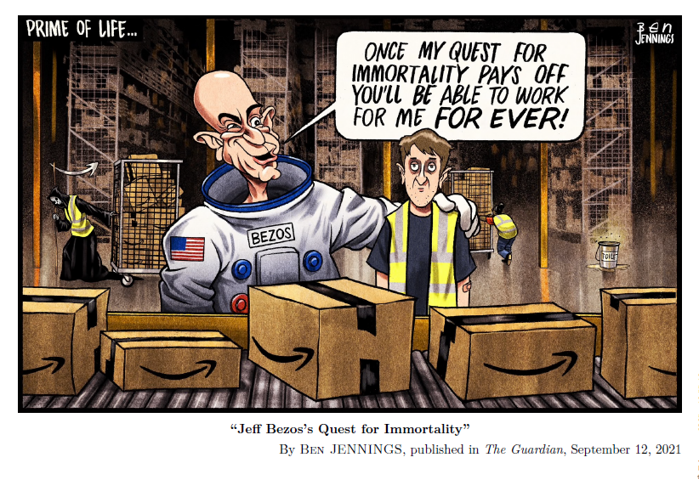
Description : a drawing by Ben Jennings displaying Jeff Bezos paternalizing an Amazon employee.
Key elements :
- Evil-looking Bezos, who is wearing a space suit to symbolize his race for space, is announcing his quest to become immortal to a disgruntled employee. Billionaires have so much power that they can now envision beating death.
- In fact, the Grim Reaper himself is in the background, and his scythe, shaped like the Amazon logo, is coming for the tired employee, who seems to be condemn to work himself to death serving the greedy billionaire.

